

**CZ3005 Artificial Intelligence**

**Assignment 3**

Done by:

U1920095H Claudia Beth Ong

Tutorial Group: TS4

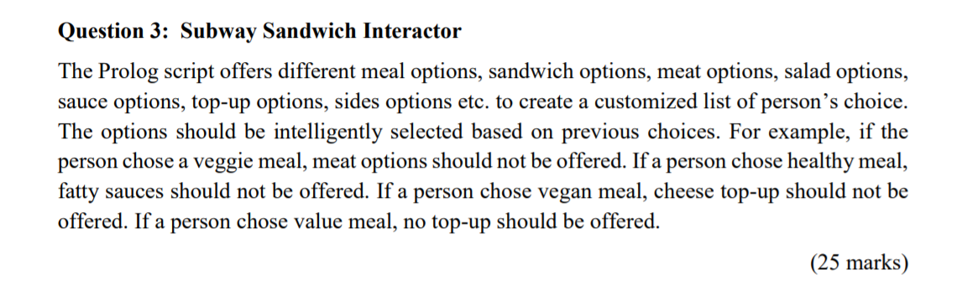

1. **Knowledge Base (KB)**

These are the options available for each part of the subway meal. Some options are not offered if the user chooses a non-normal meal. For example, if the user chooses a vegetarian meal, they will not be able to choose any mains (meats). The logic will be further explained later.

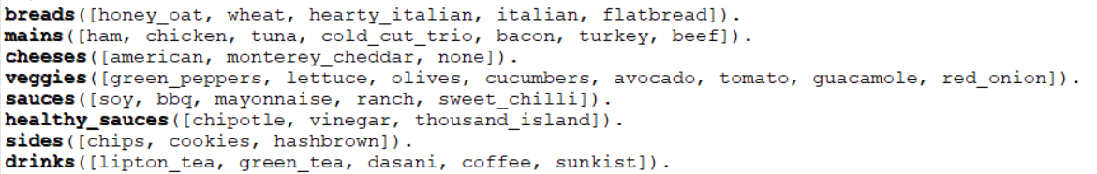

Options:

|  |  |
| --- | --- |
| Breads | 1. Honey Oat 2. Wheat 3. Hearty Italian 4. Italian 5. Flatbread |
| Mains | 1. Ham 2. Chicken 3. Tuna 4. Cold Cut Trio 5. Bacon 6. Turkey 7. Beef |
| Cheese | 1. American 2. Monterey Cheddar 3. None |
| Veggies | 1. Green peppers 2. Lettuce 3. Olives 4. Cucumbers 5. Avocado 6. Tomato 7. Guacamole 8. Red Onion |
| Sauces | 1. Soy 2. BBQ 3. Mayonnaise 4. Ranch 5. Sweet Chilli |
| Healthy sauces | 1. Chipotle 2. Vinegar 3. Thousand Island |
| Sides | 1. Chips 2. Cookies 3. Hashbrown |
| Drinks | 1. Lipton tea 2. Green tea 3. Dasani 4. Coffee 5. Sunkist |

**2. Dynamic Predicates**

These are the dynamic predicates used in the program. They are allowed to be modified at runtime so that the user’s choices are stored, and another function will print the final options of the user once the user is done choosing all the parts of the meal.



**3. Flow of Program**

The program starts when the user types

start.

Then, the program calls the prompt function which starts off by asking the user what meal type they want.

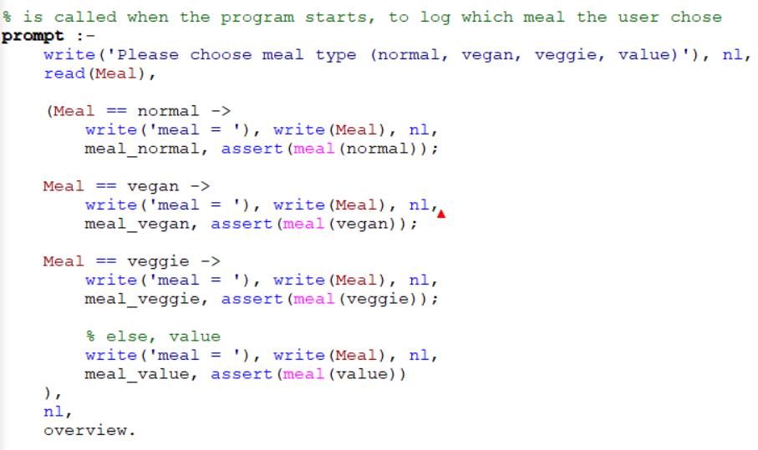

**4. Cases and Options Available**

For each meal, the user will be allowed to choose from different options available. The normal meal allows the user to choose from every single option, while the vegan, veggie and value meals have restrictions. The available options are as stated below.

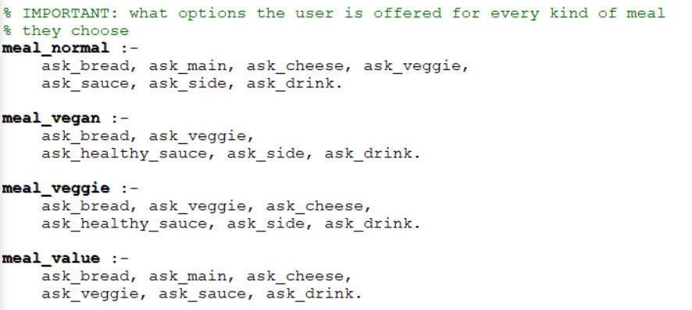

|  |  |
| --- | --- |
| **Meal** | **Options** |
| Normal | 1. Bread 2. Main (Meat) 3. Cheese 4. Veggie 5. Sauce 6. Sides 7. Drink |
| Vegan | 1. Bread 2. Veggie 3. Healthy Sauces 4. Sides 5. Drinks |
| Veggie | 1. Bread 2. Veggie 3. Cheese 4. Healthy Sauces 5. Sides 6. Drinks |
| Value | 1. Bread 2. Main (Meat) 3. Cheese 4. Veggie 5. Sauce 6. Drink |

**5. Example of Program**

